 October 16, 2025

Functionality Attestation (FA)

SUBJECT: Cisco Global Certification Team (GCT) Defense Programs (DP) Internal Compliance Review (ICR) Functionality Attestation (FA) of the Cisco Session Border Controller (SBC)
References:
(a) Defense of Defense Instruction (DoDI) 8100.04, “Department of Defense (DoD) Unified Capabilities (UC),” 09 December 2010
(b) Office of the DoD Chief Information Officer (CIO), “DoD Unified Capabilities Requirements 2013 (UCR 2013) Change 2,” September 2017
(d) Cisco GCT DP, “Cybersecurity Summary Report (CSR) for Cisco Session Border Controller (SBC), Software Rel. IOS XE 17.18”
(e) Test procedures

- Internal Compliance Authority. The Cisco GCT DP is designated as the attestation authority responsible for overseeing and validating the DTR process to ensure adherence to established Cybersecurity (CS) and FA standards.

- Conditions of Attestation. The Cisco SBC running Software Rel. Internetwork
Operating System (IOS) XE 17.18 (System Under Test, or SUT) has been attested for joint use and meets the essential High Availability (HA) SBC requirements outlined in the UCR 2013, Reference (b). This attestation remains valid under the condition listed
in Table 1 Conditions and will expire if any changes affecting interoperability are made, or on the date specified in the Cisco GCT DP DTR List.

Table 1. Conditions
TDR # | Description | Operational Impact | Remarks
CIS-1824-001 | MLPP call fails to produce Audio upon preemption | CLOSED | DISA accepted the Vendor’s POA&M and adjudicated this discrepancy as minor.

- System Requirements identification and Test Configuration. The SUT, identified as the Cisco SBC with Software Rel. IOS XE 17.18 (detailed in Table 2-1), was tested
by Cisco GCT DP. This testing was conducted in functional setup. Figure 2-2 illustrates the SUT test configuration, including its components and connectivity schemes, which were consistently employed for both FA and CS testing.
Table 2-1. System Requirements Identification
System Identification
System Name | Cisco SBC
Increment and/or Version | IOS XE 17.18
Product Category | SBC with High Availability
Cisco Point of Contact
Tracking
DTR ID | 003 (ISR 4000 Series, ASR 1000 Series, C8000v, and C8000 Series)
Requirement Source
Unified Capabilities Requirement | UCR 2013, Change 2, Sections 2, 4, and 5
Remarks | None
Test Organization | Cisco GCT DP

Figure 2-2. SUT Test Configuration

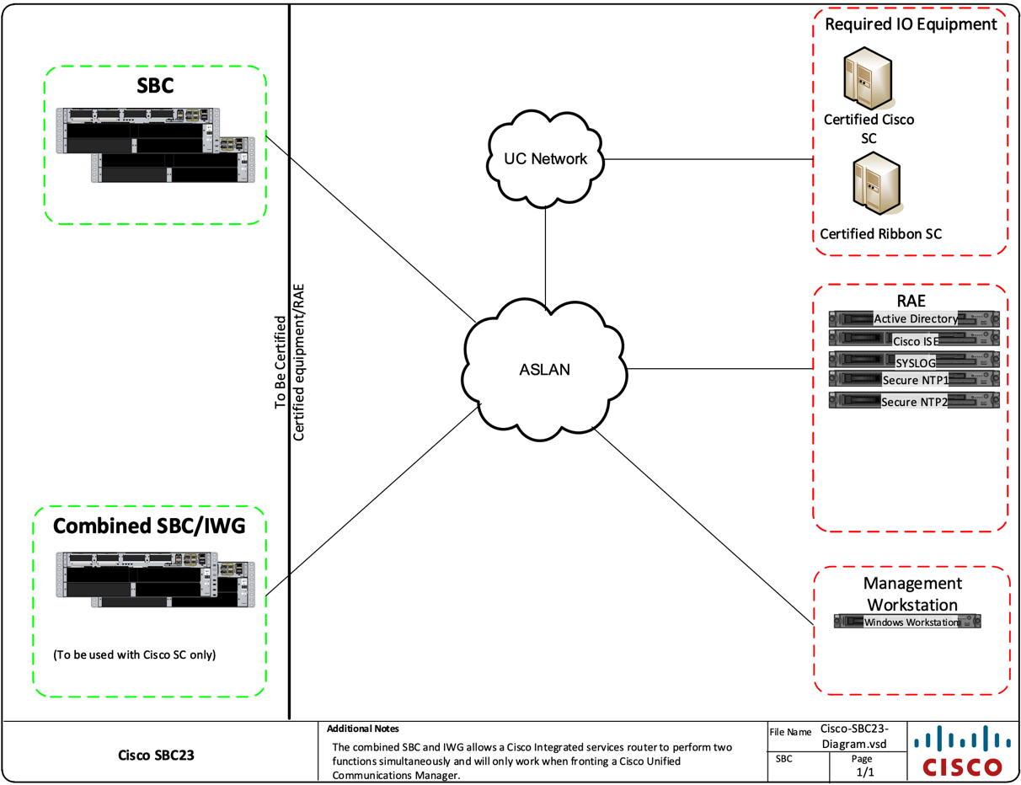

- System Description
  - General Description. The SUT is an SBC, which performs voice firewall and back-to-back user agent functions. The SBC consists of the voice or video firewall/border controller. The Call Connection Agent (CCA) in the Softswitch (SS) and Local Session Controller (LSC) needs to interact with Assured Services Session Initiation Protocol (AS-SIP) functions in the SBC which:

    - Mediates AS-SIP signaling between a Session Controller (SC) and a Wide Area Network (WAN) SS, and between two SSs.
    - Supports SBC functions, such as Network Address Translation (NAT) and Network Address and Port Translation (NAPT).
    - Supports Internet Protocol (IP) firewall functions.

SBCs can be certified in one of two availability categories: High Availability (HA) and Medium Availability. The SUT is certified for joint use as an HA SBC. The SUT supports IP firewall functions. The Cisco SBC facilitates IP to IP AS-SIP communications between SCs that support the Unified Capabilities Requirements (UCR) Alternative B failover method and their end instruments, when traversing the Unified Capabilities (UC) network. The SBC interfaces with Defense Information Systems Network (DISN) UC systems through an AS-SIP interface and provides IP to IP communications between edge LSC/Enterprise Session Controller (ESC) and core (Softswitch) segments in the UC network. Additional functions include AS-SIP signaling and encryption services to allow end to end communications on the UC network. This SBC solution consists of the Cisco Integrated Services Router (ISR) 4000 series, Aggregation Services Router (ASR) 1000 series, Catalyst (C)8000v, C8200 series, and C8300 series of hardware platforms.
The system consists of the following components:
- SBC
- Combined SBC/Interworking Gateway (IWBC)
- IWG (Interworking Gateway)

The SBC is an intelligent unified communications network border element that provides SBC functions that help enable end-to-end IP-based transport of voice, video, and data between independent unified communications networks and the UC network.
The SBC combined with IWG type deployment provides critical Session Initiation Protocol (SIP) message normalization functionality that allows for interoperability between components within the UC architecture for the Cisco SC. The combined SBC and IWG is an integrated Cisco IOS XE software application that runs on the Cisco ISR 4000 series, ASR 1000 series, C8000v, C8200 series, and C8300 series of hardware platforms.
  - Management Description. The SBC is managed with a site-provided, Security Technical Implementation Guideline (STIG)-compliant, Common Access Card (CAC)-enabled Windows Operating System workstation. After initial configuration, administrative tasks are performed using a Secure Shell (SSH) version (v)2 (SSHv2) connection. A local emergency account is configured for cases when the Active Directory server is unavailable. The emergency administrative account meets password complexity requirements enforced by local policy enforcement.

- Operational Architecture. The DoDIN architecture is structured as a two-level network hierarchy, comprising DISN backbone switches and Service/Agency installation switches. The specific type of switch permitted at any given location is determined by DoD Chief Information Officer and Joint Staff policy, along with subscriber mission requirements. Consequently, the DoDIN architecture incorporates various categories of switches. This notional operational DoDIN architecture, which illustrates where the SUT may be utilized, is depicted in Figure ES.1. UC High Level Operational Framework within the Department of Defense (DoD) Unified Capabilities Master Plan (UC MP).

- Test Details. This attestation is based on functionality testing. Cisco GCT DP conducted functionality testing from 15 May 2025 through 19 May 2025, using test procedures derived from Reference (e). Cisco is tracking on open TDRs found in Table 1. Cisco GCT DP conducted CS testing, with the results documented in a separate report (Reference (d)).

DTR 2 was requested to update the IOS XE software version from 17.12 to 17.15 for the
product component IWBC on the ISR 4461 series of router platforms and update the
ESXi software version from 7.0.3 to 8.0.3.

DTR 3 was a request to update the IOS XE Software Release version from 17.15 to 17.18 for the product components IWBC, IWG, and SBC on the ASR 1006-X, ISR
4461/K9, C8300 series, C8200 series, and 8000v series of router platforms.

- Functionality Status. Table 3 provides the SUT interface functionality status; Table 4 provides the SUT hardware, software and firmware versions; and Table 5
provides the Capability Requirements.
Table 3. SUT Interface Status
Network Management Interfaces
Interface | Applicability | Status | Remarks
IEEE 802.3i (10BaseT UTP) | C | Met | The SUT met the critical CRs and FRs for the IEEE 802.3i.
IEEE 802.3u (100BaseT UTP) | C | Met | The SUT met the critical CRs and FRs for the IEEE 802.3u.
Network Interfaces
Interface | Applicability | Status | Remarks
IEEE 802.3ab (1000BaseT UTP) | C | Met | The SUT met the critical CRs and FRs for the IEEE 802.3ab.
IEEE 802.3z (1000BaseX Fiber) | C | Met | The SUT does not support this interface.
IEEE 802.3ae (10GBaseX) | C | Met (See Note 2) | The SUT met the critical CRs and FRs for the IEEE 802.3ae.
IEEE 802.3an (10GBaseT UTP) | C | Met | The SUT met the critical CRs and FRs for the IEEE 802.3an.
IEEE 802.3ba (100GBaseX Fiber) | C | Not Tested | The SUT does not support this interface.
NOTE(S):
- Per the UCR, the SUT can support any one of these conditional interfaces. Table 3 depicts the SUT high-level requirements category and the applicability of each sub-requirement.
- The 10GBaseX WAN interfaces were not tested but are included and certified for joint use on only the 4000 Series and 8300 Series. IWBCs based on Cisco GCT DP’s ICR analysis of CER test data

Table 4. SUT Hardware/Software/Firmware Version Identification

Product Identification
Product Name | Cisco SBC
Software Release | IOS XE 17.18
UCR Product Type(s) | SBC
Product Description | The SBC is an intelligent unified communications network border element that provides SC functions that help enable end-to-end IP-based transport of voice, video, and data between independent unified communications networks and the DoDIN network. The Cisco SBC combined with IWG type deployment provides critical SIP message normalization functionality that allows for interoperability defined in the UCR (CORE) change 2. The combined SBC and IWG is an integrated Cisco IOS XE software application that runs on the Cisco ISR 4000 series, ASR 1000 series, C8000v, C8200 series, and C8300 series of hardware platforms.
Product Components | Component Name  (See notes 1 and 2.) | Sub-Component | Tested Version | Function
IWBC | 4321 ISR | NA | IOS XE 17.12.2 | Provides connectivity to AS-SIP trunks.
IWBC | 4331 ISR | NA | IOS XE 17.12.2 | Provides connectivity to AS-SIP trunks.

Product Components | Component Name  (See notes 1 and 2.) | Sub-Component | Tested Version | Function
IWBC | 4351 ISR | NA | IOS XE 17.12.2 | Provides connectivity to AS-SIP trunks.
IWBC | 4431 ISR | NA | IOS XE 17.12.2 | Provides connectivity to AS-SIP trunks.
IWBC | 4451-X ISR | NA | IOS XE 17.12.2 | Provides connectivity to AS-SIP trunks.
IWBC | 4461 ISR | NA | IOS XE 17.18.1a | Provides connectivity to AS-SIP trunks. (See note 3)
IWBC | ASR 1001-X | NA | IOS XE 17.12.2 | Provides connectivity to AS-SIP trunks.
IWBC | ASR 1002-X | NA | IOS XE 17.12.2 | Provides connectivity to AS-SIP trunks.
IWBC | ASR 1004 | NA | IOS XE 17.12.2 | Provides connectivity to AS-SIP trunks.
IWBC | ASR 1006 | NA | IOS XE 17.12.2 | Provides connectivity to AS-SIP trunks.
IWBC | ASR1006-X | NA | IOS XE 17.18.1a | Provides connectivity to AS-SIP trunks. (See note 4)
IWBC | C8200-1N-4T  C8200L-1N-4T | NA | IOS XE 17.18.1a | Provides connectivity to AS-SIP trunks. (See note 4)
IWBC | C8300-1N1S-4T2X | NA | IOS XE 17.18.1a | Provides connectivity to AS-SIP trunks. (See note 4)
IWBC | C8300-2N2S-4T2X | NA | IOS XE 17.18.1a | Provides connectivity to AS-SIP trunks. (See note 4)
IWBC | C8300-1N1S-6T | NA | IOS XE 17.18.1a | Provides connectivity to AS-SIP trunks. (See note 4)
IWBC | C8300-2N2S-6T | NA | IOS XE 17.18.1a | Provides connectivity to AS-SIP trunks. (See note 4)
IWBC | C8000v | ESXi Server Host | IOS XE 17.18.1a | Provides connectivity to AS-SIP trunks. (See note 4)
SBC | 4321 ISR | NA | IOS XE 17.12.2 | Provides connectivity to AS-SIP trunks.

Product Components | Component Name  (See notes 1 and 2.) | Sub-Component | Tested Version | Function
SBC | 4331 ISR | NA | IOS XE 17.12.2 | Provides connectivity to AS-SIP trunks.
SBC | 4351 ISR | NA | IOS XE 17.12.2 | Provides connectivity to AS-SIP trunks.
SBC | 4431 ISR | NA | IOS XE 17.12.2 | Provides connectivity to AS-SIP trunks.
SBC | 4451-X ISR | NA | IOS XE 17.12.2 | Provides connectivity to AS-SIP trunks.
SBC | 4461 ISR | NA | IOS XE 17.18.1a | Provides connectivity to AS-SIP trunks. (See note 3)
SBC | ASR 1001-X | NA | IOS XE 17.12.2 | Provides connectivity to AS-SIP trunks.
SBC | ASR 1002-X | NA | IOS XE 17.12.2 | Provides connectivity to AS-SIP trunks.
SBC | ASR 1004 | NA | IOS XE 17.12.2 | Provides connectivity to AS-SIP trunks.
SBC | ASR 1006 | NA | IOS XE 17.12.2 | Provides connectivity to AS-SIP trunks.
SBC | ASR1006-X | NA | IOS XE 17.18.1a | Provides connectivity to AS-SIP trunks. (See note 4)
IWG | 4321 ISR | NA | IOS XE 17.12.2 | Provides connectivity to AS-SIP trunks.
IWG | 4331 ISR | NA | IOS XE 17.12.2 | Provides connectivity to AS-SIP trunks.
IWG | 4351 ISR | NA | IOS XE 17.12.2 | Provides connectivity to AS-SIP trunks.
IWG | 4431 ISR | NA | IOS XE 17.12.2 | Provides connectivity to AS-SIP trunks.
IWG | 4451-X ISR | NA | IOS XE 17.12.2 | Provides connectivity to AS-SIP trunks.
IWG | 4461 ISR | NA | IOS XE 17.18.1a | Provides connectivity to AS-SIP trunks. (See note 3)
IWG | ASR 1001-X | NA | IOS XE 17.12.2 | Provides connectivity to AS-SIP trunks.

Product Components | Component Name  (See notes 1 and 2.) | Sub-Component | Tested Version or Release(?) | Function
IWG | ASR 1002-X | NA | IOS XE 17.12.2 | Provides connectivity to AS-SIP trunks.
IWG | ASR 1004 | NA | IOS XE 17.12.2 | Provides connectivity to AS-SIP trunks.
IWG | ASR 1006 | NA | IOS XE 17.12.2 | Provides connectivity to AS-SIP trunks.
IWG | ASR1006-X | NA | IOS XE 17.18.1a | Provides connectivity to AS-SIP trunks. (See note 4)
IWBC | C8000v | ESXi Server Host | IOS XE 17.18.1a | Provides connectivity to AS-SIP trunks. (See note 4)
IWBC, IWG, SBC | ESXi Server Host | NA | ESXi 8.0.3, 2402251
IWBC, IWG, SBC | Management Workstation  (Site-provided) | NA | Windows 11  Enterprise, v22H2
IWBC, IWG, SBC | Management Workstation  (Site-provided) | NA | ActivClient 7.2.1.46
IWBC, IWG, SBC | Management Workstation  (Site-provided) | NA | Axway Desktop  Validator SE  5.0.3.0052
IWBC, IWG, SBC | Management Workstation  (Site-provided) | NA | SecureCRT v9.3.2  (x64 build 2978)
NOTE(S):
- The SUT was initially certified with Software Release IOS XE 17.12. The IOS XE Software Release version was updated via subsequent DTR(s) as follows: DTR002 from 17.12 to 17.15; DTR003 from 17.15 to 17.18.
- Cisco GCT DP tested the bolded and underlined components/sub-components. The remaining items in the family series were not directly tested but are certified for joint use because they share the same software and similar hardware as the tested components. Based on Cisco GCT DP's analysis, they are functionally identical for IO certification purposes.
- For the ISR 4461 series, the IOS XE Software Release was updated from 17.12 to 17.15 with DTR002, and from 17.15 to 17.18 with DTR0003, both via analysis (no testing). These updates were supported by prior testing and certification of the respective software versions during the initial Cisco Softswitch (SS) test event under DTR00X.
- For the ASR 1006-X, C8300, C8200, and C8000v router platforms, the IOS XE Software Release was updated from 17.12 to 17.15 with DTR001, and from 17.15 to 17.18 with DTR003. The initial update was based on testing and certification during the DTR00X Cisco ESC test event, while the subsequent update to 17.18 was approved via analysis (no additional testing), supported by previous DTR00X certification.
- With DTR002, the ESXi Software Release version was updated from 7.0.3 to 8.0.3 via analysis (no testing) based on testing and certification of this software version during the initial test event for Cisco SS.

Table 5. SUT Capability Requirements and Functional Requirements Status

CR/FR ID | UCR Requirement (High-Level) | Applicability  (See note 1.) | UCR 2013  Change 2 | Status
1 | SC and SS Failover and Recovery | Required | 2.6 | Met (See note 2.)
 | SC Failover: Alternative A: The SC-Generated  OPTIONS Method | Optional | 2.6.1 | Not Tested (See note 2.)
 | SC Failover: Alternative B: The SBC-Generated  OPTIONS Method | Required | 2.6.2 | Met (See note 2.)
2 | Product Interface | Required | 2.7 | Met
 | Internal Interfaces | Required | 2.7.1 | Met
 | External Interfaces | Required | 2.7.2 | Met
 | EMS Interfaces | Required | 2.7.4 | Met
3 | AS-SIP IP Gateway | Conditional | 2.11 | Met
 | AS-SIP IP Gateway Media Interworking | Conditional | 2.11.2 | Met
4 | Session Border Controller (SBC) Enterprise Session Controller (ESC) | Required | 2.12.4 | Met (See note 4.)
 | General SBC Functionality | Required | 2.12.4.1 | Met (See note 3.)
 | Enclave-Fronting SBC Functionality | Required | 2.12.4.2 | Met (See note 3.)
 | Enclave-Fronting SBC Functionality within the core infrastructure | Required | 2.12.4.3 | Met (See note 3.)
5 | Remote Media Gateway | Conditional | 2.16 | Met
 | Remote MG | Conditional | 2.16.13 | Met
6 | Session Border Controller | Required | 2.17 | Partially Met (See note 4.)
 | AS-SIP Back-to-Back User Agent | Required | 2.17.1 | Met
 | Call Processing Load | Required | 2.17.2 | Met
 | Network Management | Required | 2.17.3 | Met
 | DSCP Policing | Optional | 2.17.4 | Not Tested (See note 5.)
 | Codec Bandwidth Policing | Optional | 2.17.5 | Met
 | Availability | Required | 2.17.6 | Partially Met (See note 4.)
 | IEEE 802.1Q Support | Required | 2.17.7 | Met
 | Packet Transit Time | Required | 2.17.8 | Met
 | H.323 Support | Conditional | 2.17.9 | Met
 | SBC Requirements to Support Remote MG | Conditional | 2.17.10 | Met
 | SBC Support for Multiple SCs | Optional | 2.17.11 | Met
7 | Network Management | Required | 2.19 | Met (See note 7.)

CR/FR ID | UCR Requirement (High-Level) | Applicability  (See note 1.) | UCR 2013  Change 2 | Status
7 | General Management | Required | 2.19.1 | Met
 | Requirements for FCAPS Management | Required | 2.19.2 | Met (See note 4.)
8 | Cybersecurity | Required | 4.2 | Met (See note 7.)
9 | Internet Protocol version 6 | Required | Table 5.2-1 | Met
10 | AS-SIP 2013 | Required | AS-SIP | Met
NOTE(S):
- The annotation of ‘required’ refers to a high-level requirement and applicability of each sub-requirement. Refer to the UCR 2013, Change 2 (b).
- The UCR states that each SC and SBC pairing shall support OPTIONS-based failover by at least one of the following methods.
1. Alternative A: The SC-Generated OPTIONS Method or
2. Alternative B: The SBC-Generated OPTIONS Method. The SUT supports Alternative B
SBC-Generated OPTIONS Method for failover.
- This requirement applies specifically to an SBC fronting an ESC.
- The SUT met the requirements for High and Medium Availability with testing and the Vendor’s LoC, with the following exception, documented in Table 1: MLPP calls fail to produce audio upon preemption.
- The SUT does not support the optional DSCP Policing requirement.
- The SUT met the requirements for High and Medium Availability with testing and the (GCT DP) Vendor’s LoC, with the following exception, documented in Table 2: <POA&M Number>
A GCT DP test conducted CS testing and published the results in a separate report, Reference (c). In addition to the CS testing conducted by the test team, the SUT met the requirements in section 4 with the (GCT DP) Vendor’s LoC.

- Point of Contact (POC): Cisco Global Certification Team, Defense Programs
7025-2 Kit Creek Road, Research Triangle Park, North Carolina 27709
Cisco GCT DP Email: gct-dp-icr@cisco.com

Appendix 1. Acronym List
Acronym List
ASR | Aggregation Services Router
AS-SIP | Assured Services Session Initiation Protocol
APL | Approved Products List
BaseT | Megabit (Baseband Operation, Twisted Pair) Ethernet
BaseX | Megabit Ethernet over Fiber or Copper
C | Catalyst
CAC | Common Access Card
CAR | Cybersecurity Assessment Report
CCA | Call Connection Agent
CER | Customer Edge Router
CR | Capability Requirement
CIO | Chief Information Officer
CS | Cybersecurity
DISN | Defense Information Systems Network
DoD | Department of Defense
DODI | Department of Defense Instruction
DODIN | Department of Defense Information Network
DP | Defense Programs
DTR | Desktop Review
ESC | Enterprise Session Controller
ESXi | Elastic Sky X integrated
FR | Functional Requirement
GBaseT | Gigabit Ethernet over Copper
GBaseX | Gigabit Ethernet over Fiber or Copper
GCT | Global Certification Team
HA | High Availability
ICR | Internal Compliance Review
IEEE | Institute of Electrical and Electronic Engineer
ID | Identification
IOS XE | Internetwork Operating System XE
IP | Internet Protocol
ISR | Integrated Service Router
IWBC | Interworking Border Controller
IWG | Interworking Gateway
LoC | Letter of Compliance
LSC | Local Session Controller
MLPP | Multilevel Precedence and Preemption
NAT | Network Address Translation
NAPT | Network Address and Port Translation
R | Required
Rel. | Release
SBC | Session Border Controller
SC | Session Controller
SIP | Session Initiation Protocol
SS | Softswitch
STIG | Security Technical Implementation Guideline
SUT | System Under Test
UC | Unified Capabilities
UC MP | Unified Capabilities Master Plan
UCR | Unified Capabilities Requirements
UTP | Unshielded Twisted Pair
WAN | Wide Area Network

